LOAD BALANCERS
Prerequisites for AWS Load Balancer Hands-on Lab
Architecture
Internet
│
Internet Gateway
│
-----------------
| |
Public Subnet-1 Public Subnet-2
| |
EC2-1 EC2-2
Apache Web Apache Web

Step 1: Create a VPC
- Sign in to the AWS Management Console.
- Navigate to VPC.
- Click Create VPC.
- Select VPC only.
- Enter the following details:
Setting | Value
Name | LB-VPC
IPv4 CIDR | 10.0.0.0/16
IPv6 | No IPv6
Tenancy | Default
- Click Create VPC.
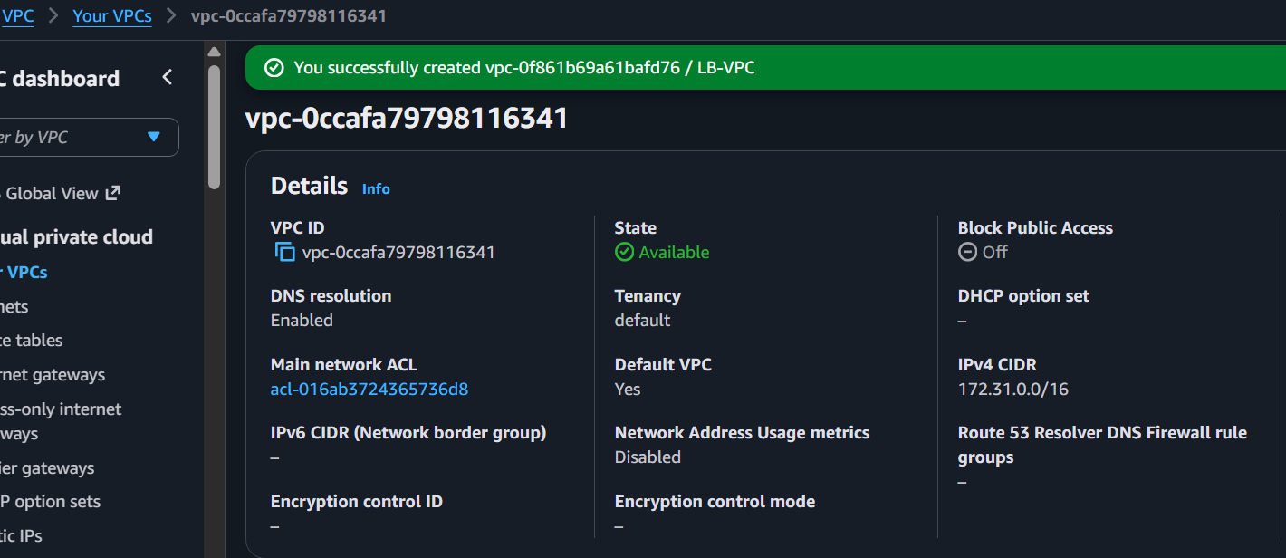

Step 2: Create Two Public Subnets
Navigate to VPC → Subnets → Create Subnet.
Public Subnet 1
Setting | Value
Name | Public-Subnet-1
VPC | LB-VPC
Availability Zone | us-east-1a (or your preferred AZ)
CIDR | 10.0.1.0/24
Click Create Subnet.
Public Subnet 2
Setting | Value
Name | Public-Subnet-2
VPC | LB-VPC
Availability Zone | us-east-1b
CIDR | 10.0.2.0/24
Click Create Subnet.
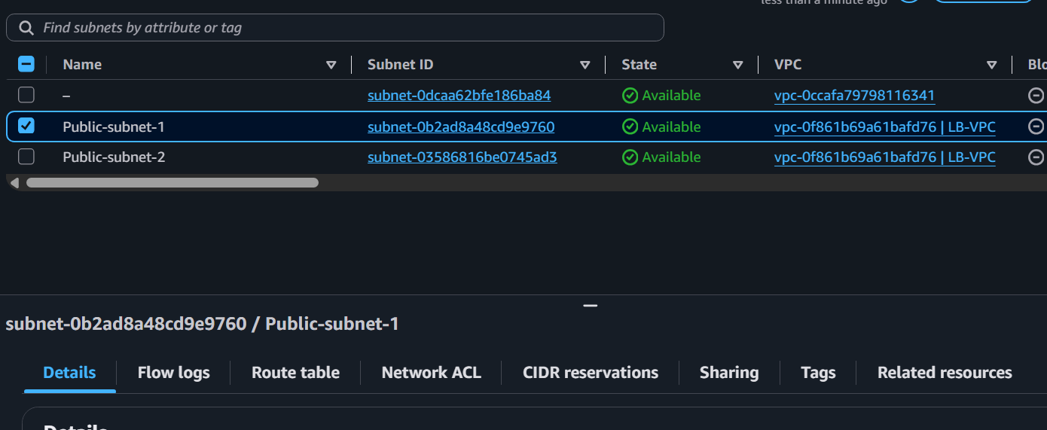

Step 3: Enable Auto Assign Public IP
For each public subnet:
- Go to VPC → Subnets.
- Select Public-Subnet-1.
- Choose Actions → Edit subnet settings.
- Enable Auto-assign public IPv4 address.
- Save.
Repeat for Public-Subnet-2.
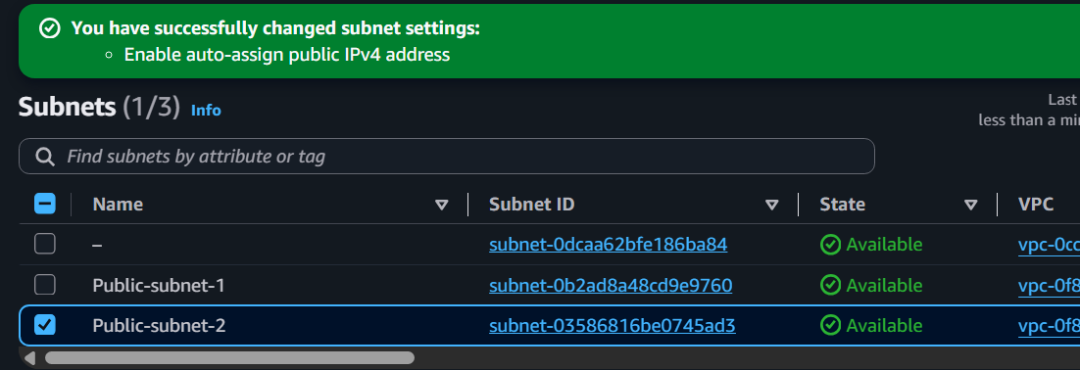

Step 4: Create Internet Gateway
- Go to VPC → Internet Gateways.
- Click Create Internet Gateway.
- Name:
LB-IGW
- Click Create.
- Select the Internet Gateway.
- Choose Actions → Attach to VPC.
- Select LB-VPC.
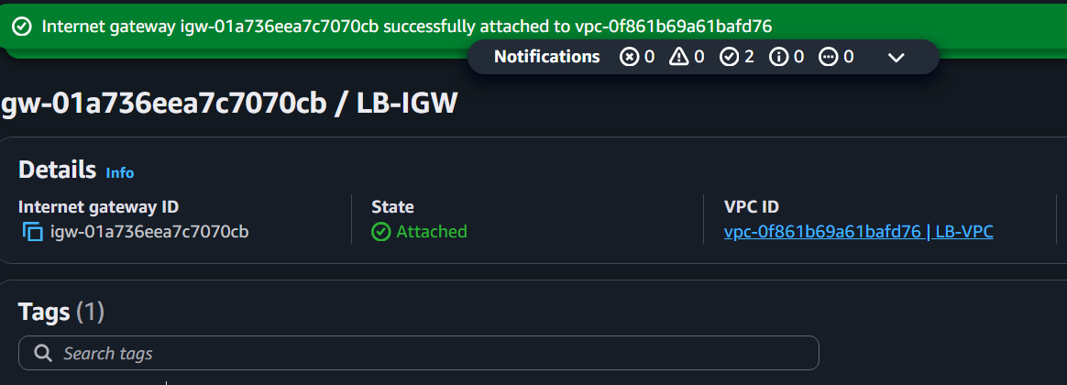

Step 5: Create Route Table
- Go to Route Tables.
- Click Create Route Table.
Setting | Value
Name | Public-RT
VPC | LB-VPC
Click Create.
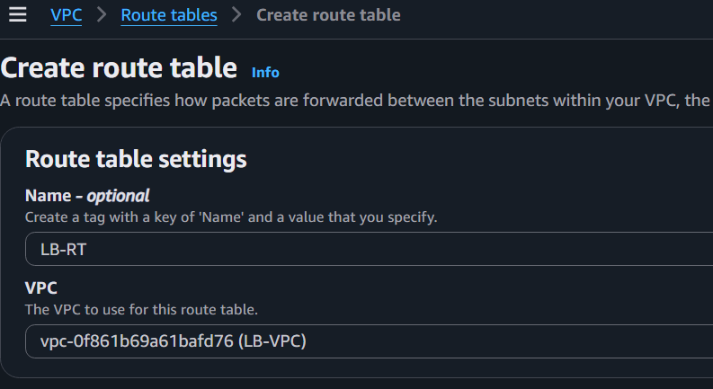

Add Internet Route
Open the Route Table.
Select Routes → Edit Routes.
Add:
Destination | Target
0.0.0.0/0 | Internet Gateway (LB-IGW)
Save.
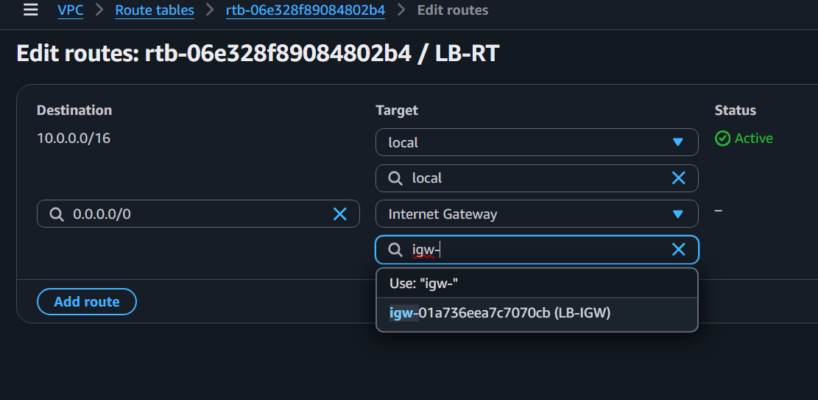

Associate Public Subnets
Open Subnet Associations.
Click Edit.
Select:
- Public-Subnet-1
- Public-Subnet-2
Save.
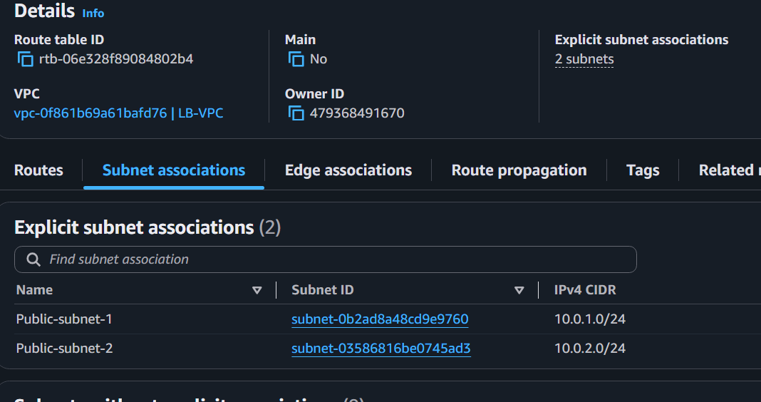

Step 6: Create Security Group
Navigate to EC2 → Security Groups → Create Security Group.
Basic Details
Setting | Value
Name | Web-SG
Description | Web Server Security Group
VPC | LB-VPC

Inbound Rules
Type | Protocol | Port | Source
SSH | TCP | 22 | My IP
HTTP | TCP | 80 | Anywhere (0.0.0.0/0)
HTTPS | TCP | 443 | Anywhere (0.0.0.0/0)
Click Create Security Group.
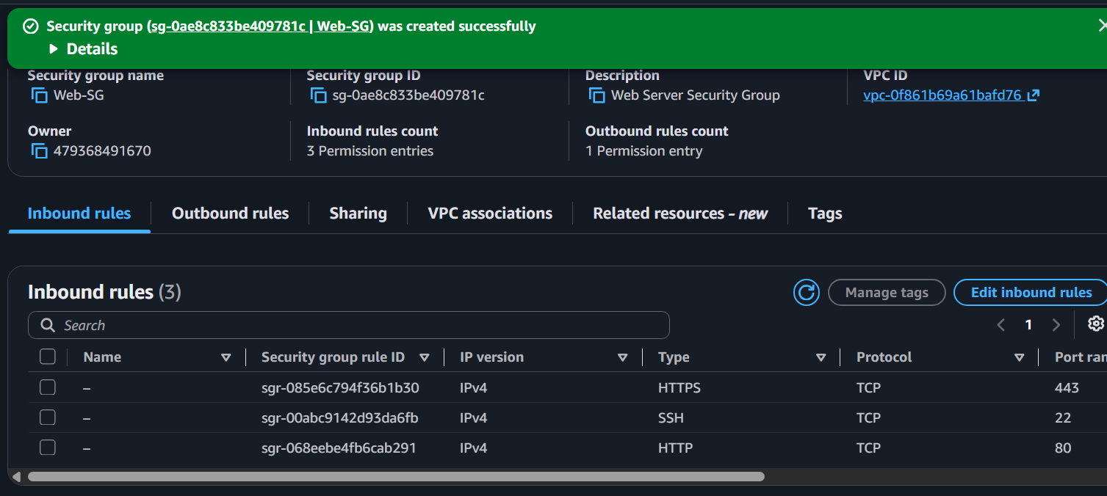

Step 7: Launch EC2 Instance 1
Go to EC2 → Launch Instance.
Configure
Setting | Value
Name | WebServer-1
AMI | Amazon Linux 2023
Instance Type | t2.micro
Key Pair | Select existing key
Network | LB-VPC
Subnet | Public-Subnet-1
Auto Assign Public IP | Enable
Security Group | Web-SG
Launch the instance.
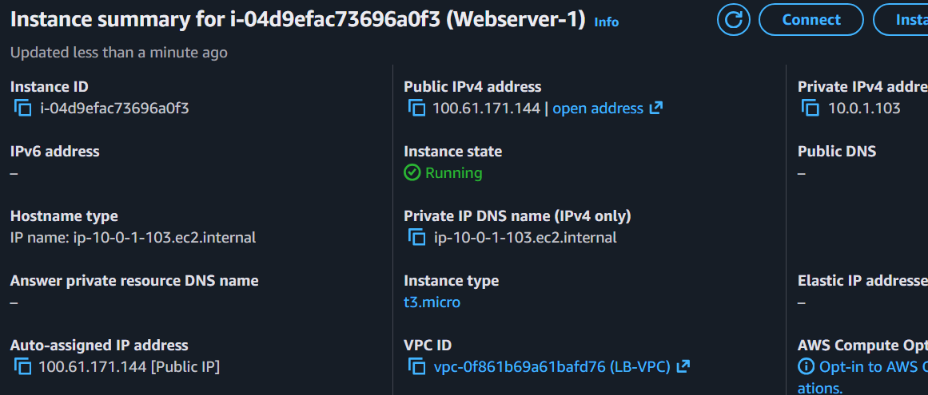

Step 8: Launch EC2 Instance 2
Launch another instance.
Setting | Value
Name | WebServer-2
AMI | Amazon Linux 2023
Instance Type | t2.micro
Key Pair | Same key
Network | LB-VPC
Subnet | Public-Subnet-2
Auto Assign Public IP | Enable
Security Group | Web-SG
Launch.
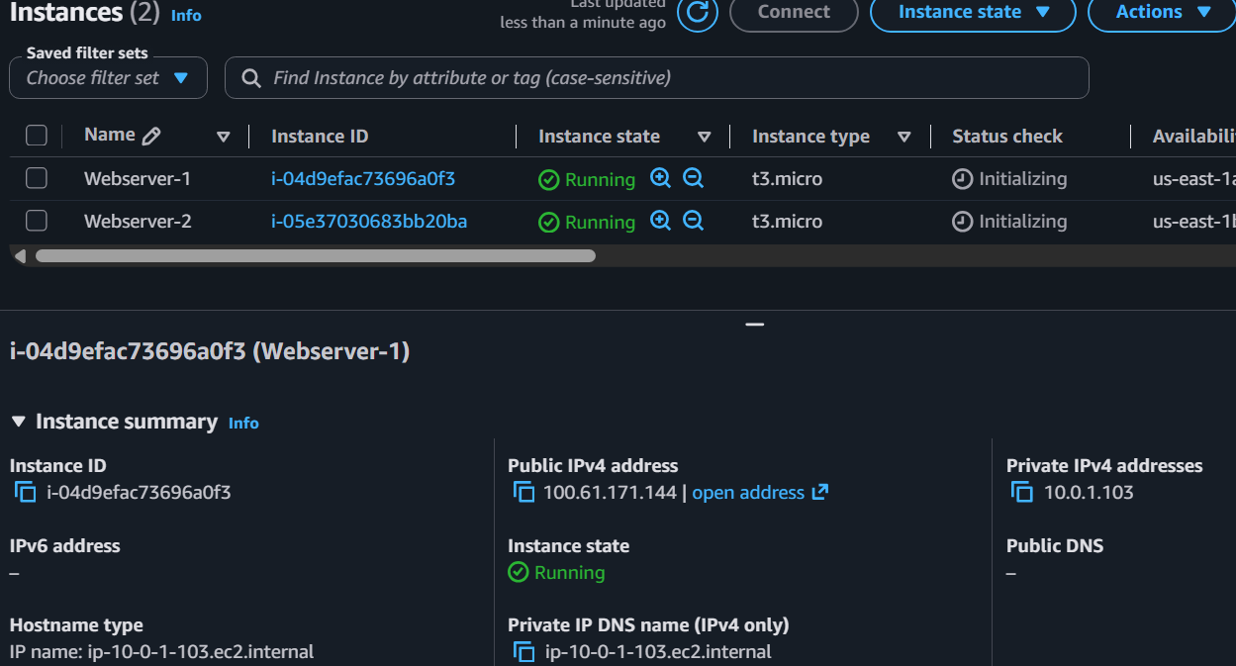

Step 9: Connect to EC2 Instance 1
ssh -i your-key.pem ec2-user@<Public-IP-of-EC2-1>
Update packages:
sudo dnf update -y
Install Apache:
sudo dnf install httpd -y
Start Apache:
sudo systemctl enable httpd
sudo systemctl start httpd
Check status:
sudo systemctl status httpd
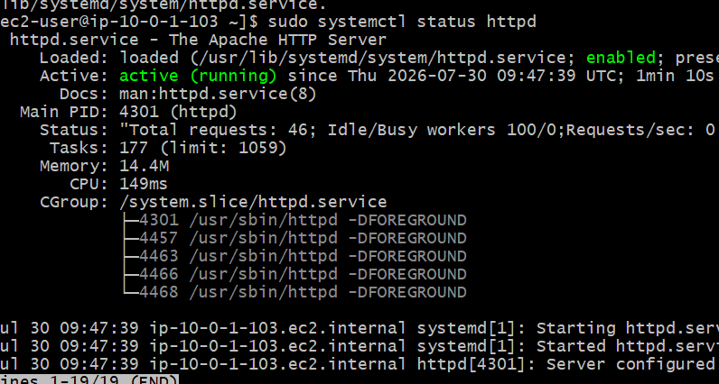
Create a webpage:
echo "<h1>This is Web Server 1</h1>" | sudo tee /var/www/html/index.html
Test locally:
curl localhost
Expected output:
<h1>This is Web Server 1</h1>
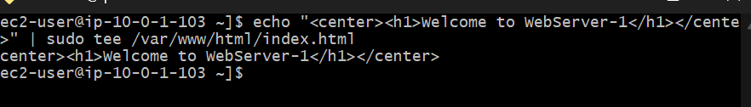

Step 10: Connect to EC2 Instance 2
ssh -i your-key.pem ec2-user@<Public-IP-of-EC2-2>
Install Apache:
sudo dnf update -y
sudo dnf install httpd -y
sudo systemctl enable httpd
sudo systemctl start httpd
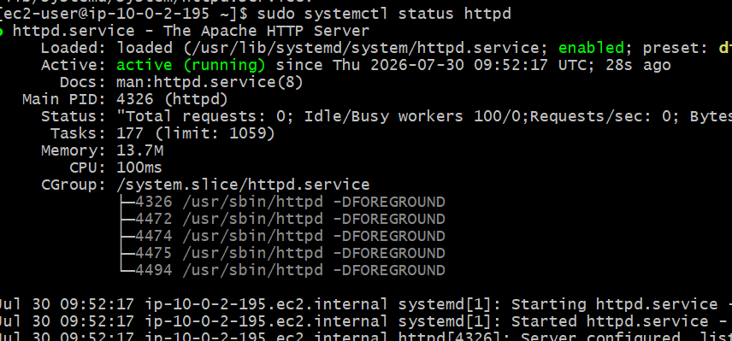
Create another webpage:
echo "<h1>This is Web Server 2</h1>" | sudo tee /var/www/html/index.html
Verify:
curl localhost
Expected output:
<h1>This is Web Server 2</h1>
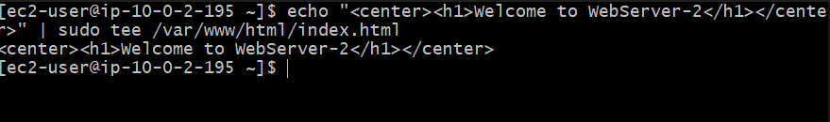

Step 11: Test Using Browser
Open:
http://<EC2-1-Public-IP>
Expected:
This is Web Server 1
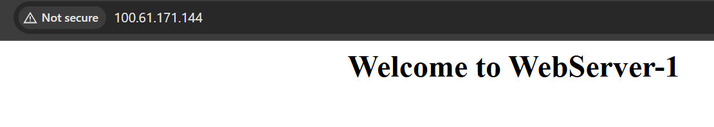
Open:
http://<EC2-2-Public-IP>
Expected:
This is Web Server 2
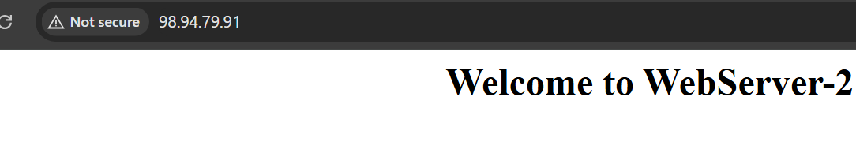

TASK 1: Configure Classic Load Balancer (CLB)

Step 1
Open
EC2
Left panel
Load Balancers
Click
Create Load Balancer
Choose
Classic Load Balancer
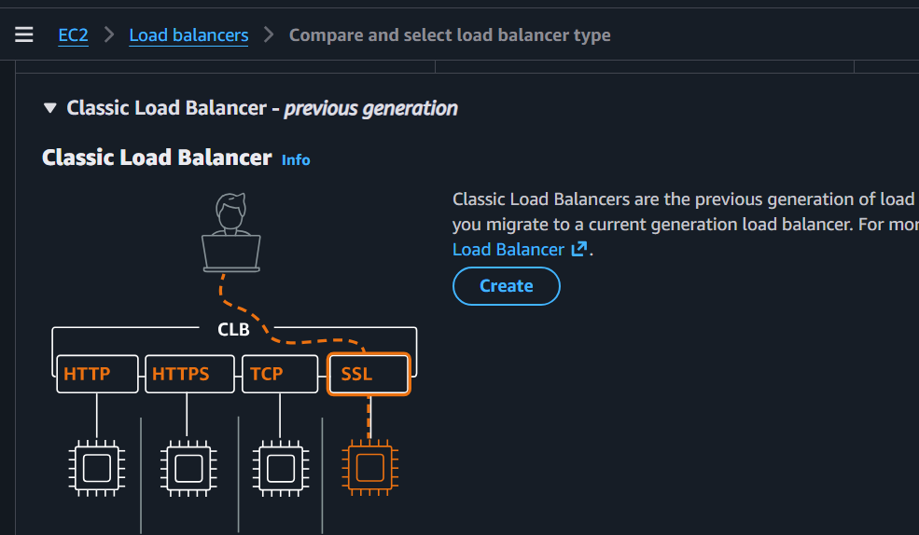

Configure
Name
Classic-LB
Scheme
Internet Facing
Listeners
HTTP 80
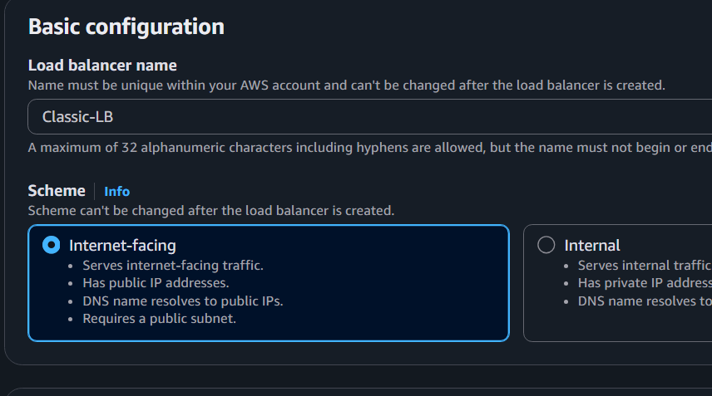

Choose
VPC
Select
Public Subnet 1
Public Subnet 2
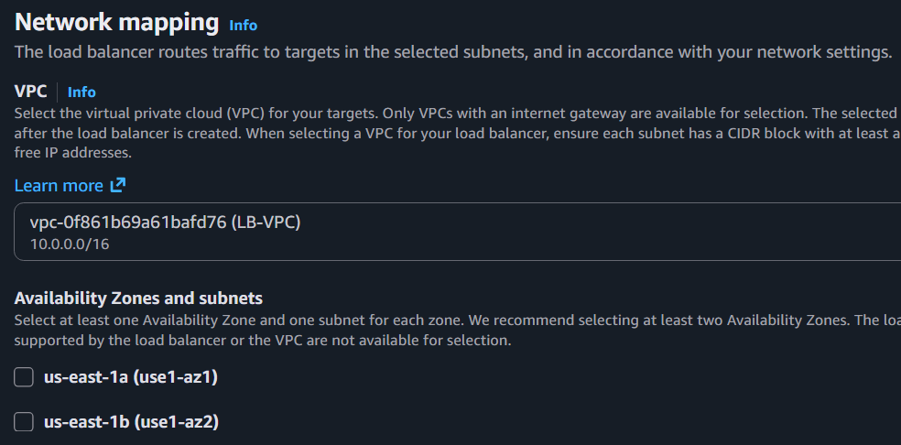

Security Group
Select existing SG
Allow HTTP
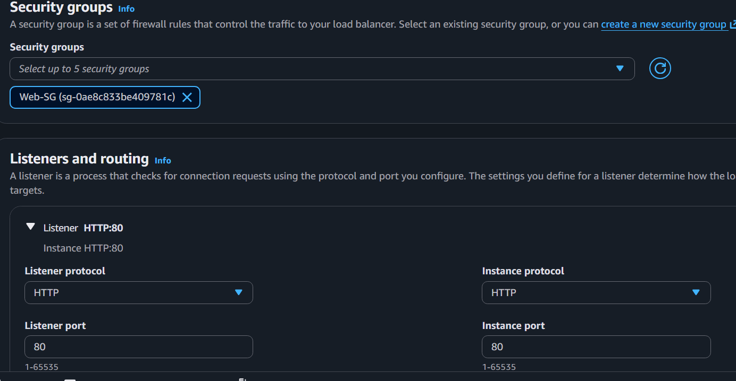

Health Check
Ping Protocol : HTTP
Ping Port : 80
Ping Path : /
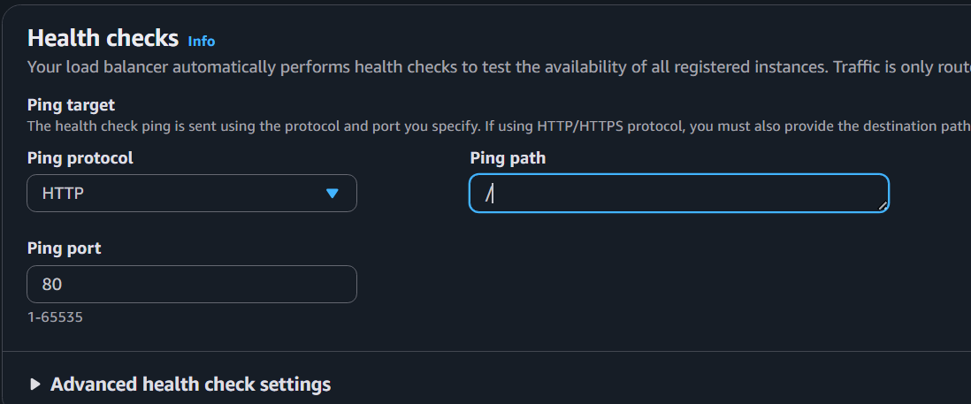
Healthy Threshold-2
Unhealthy Threshold-2
Interval-30
Timeout -5
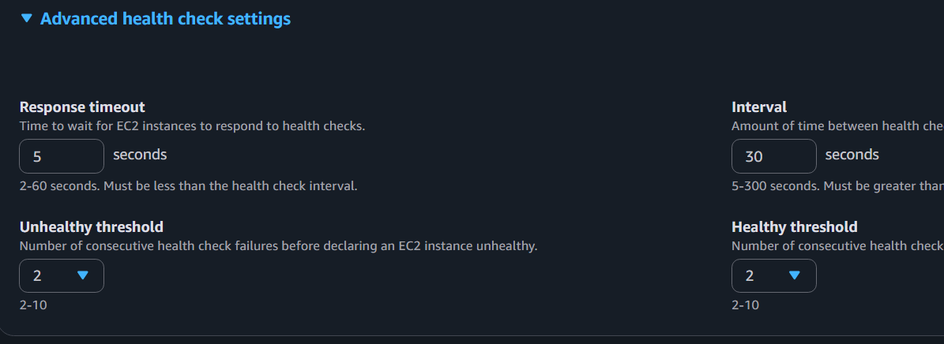

Register Targets
Select
EC2-1
EC2-2
Create
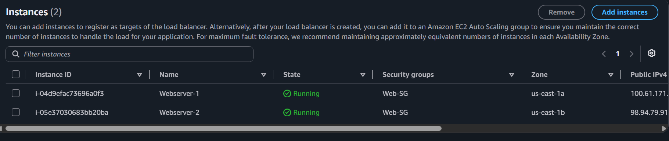
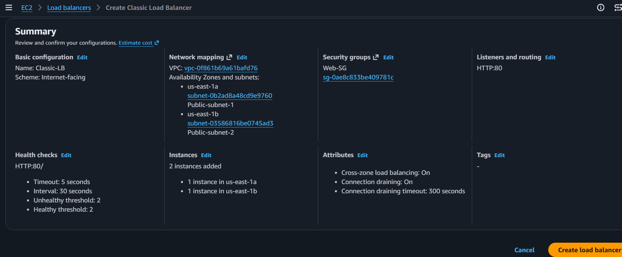

After few minutes
Copy DNS
Example
classic-lb-123456.eu-north-1.elb.amazonaws.com
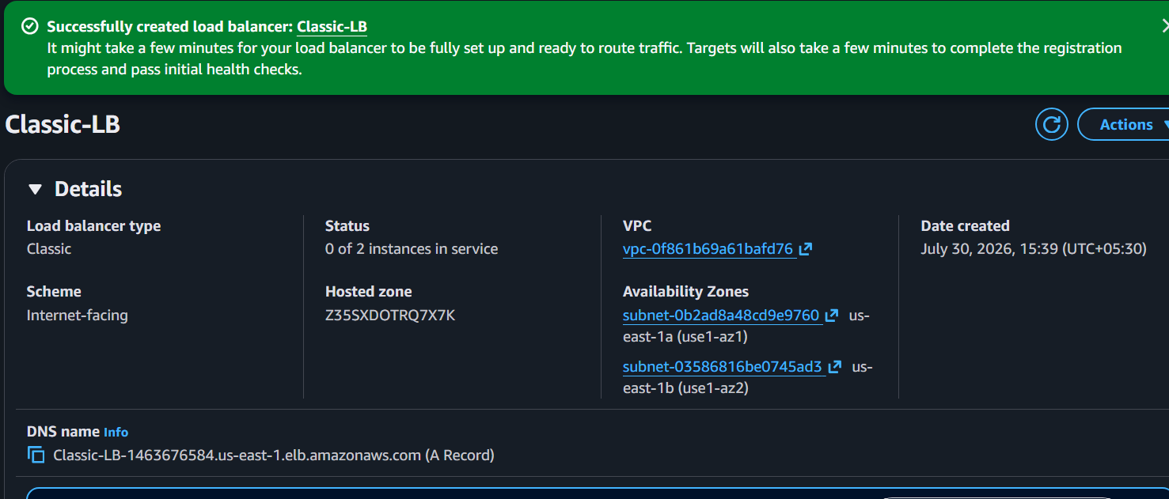
Open browser
Refresh
You should see
Server 1
Server 2
Server 1
Server 2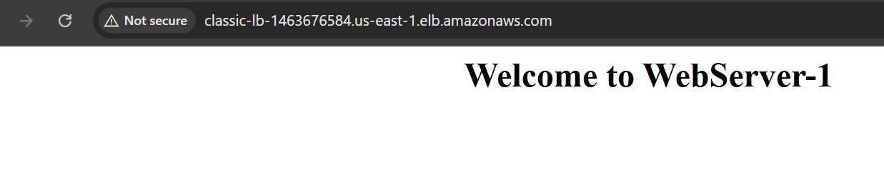
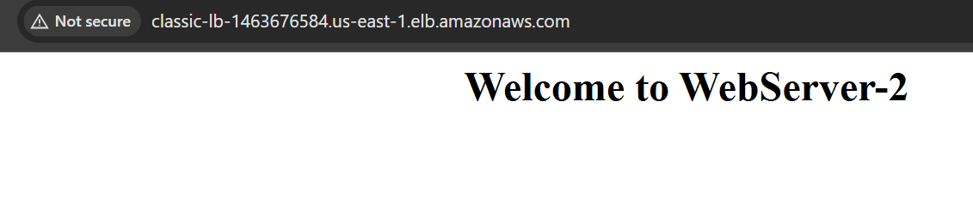

TASK 2: Configure Application Load Balancer

Open
EC2
Load Balancers
Create Load Balancer
Choose
Application Load Balancer
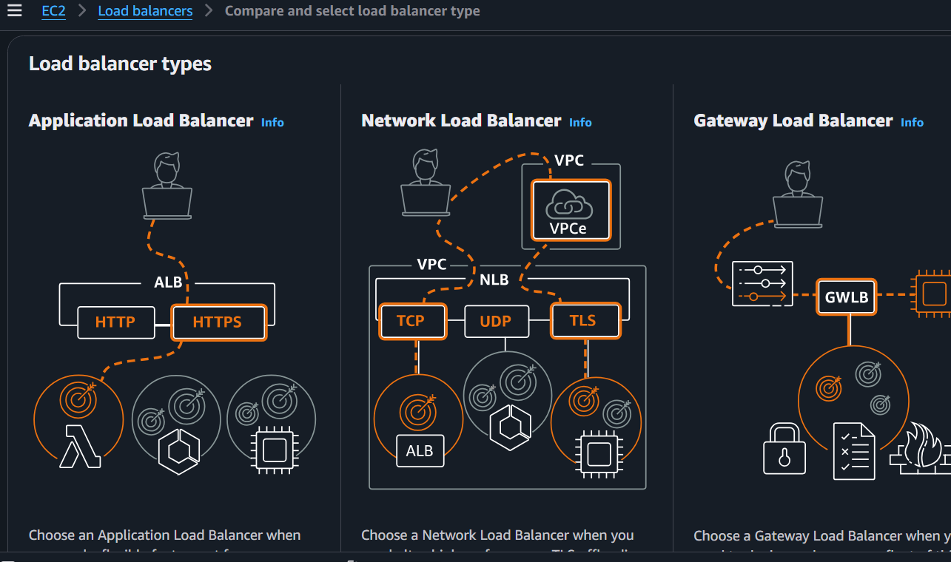

Name
Application-LB
Scheme
Internet Facing
IP
IPv4
Listeners
HTTP 80
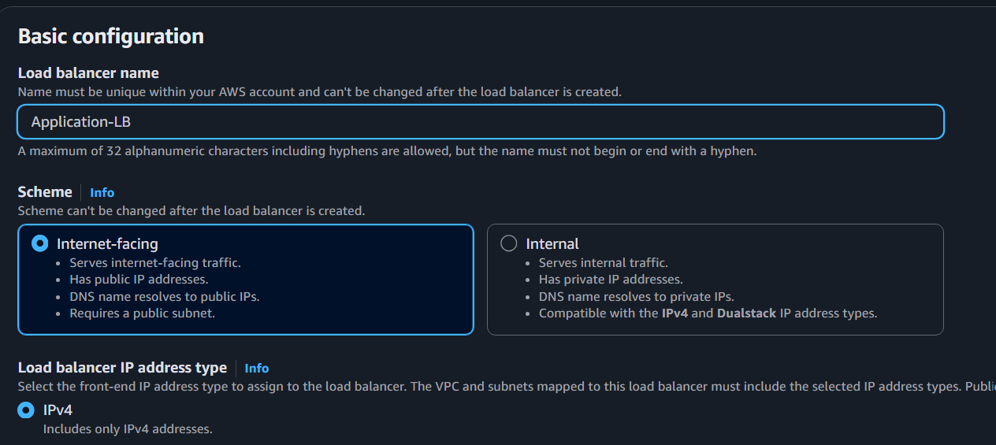

Networking
Choose
Same VPC
Select
Public Subnet A
Public Subnet B
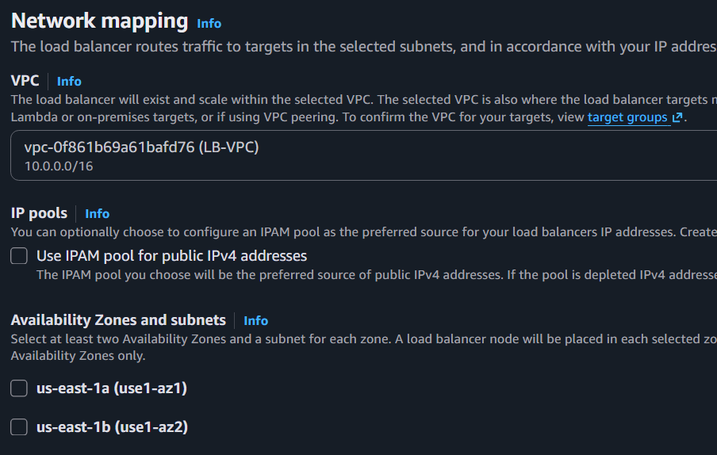

Security Group
Choose
Allow HTTP
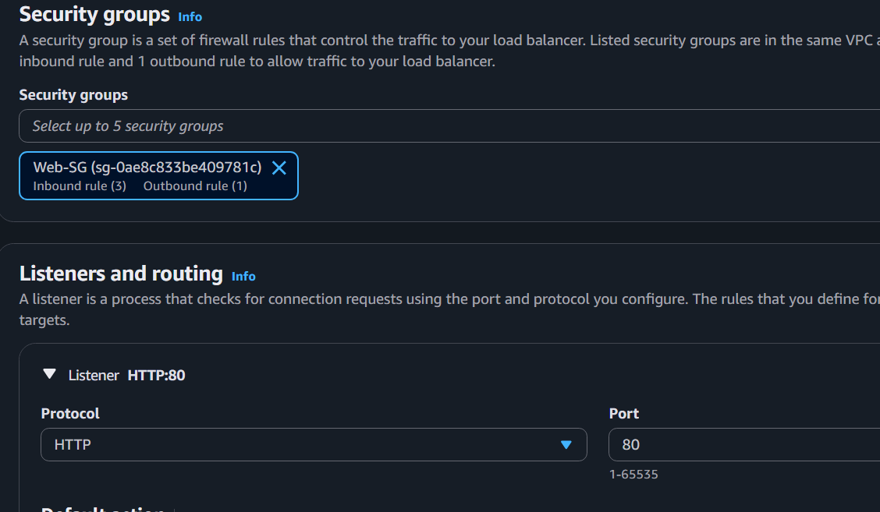

Create Target Group
Type
Instances
Protocol
HTTP
Port
80
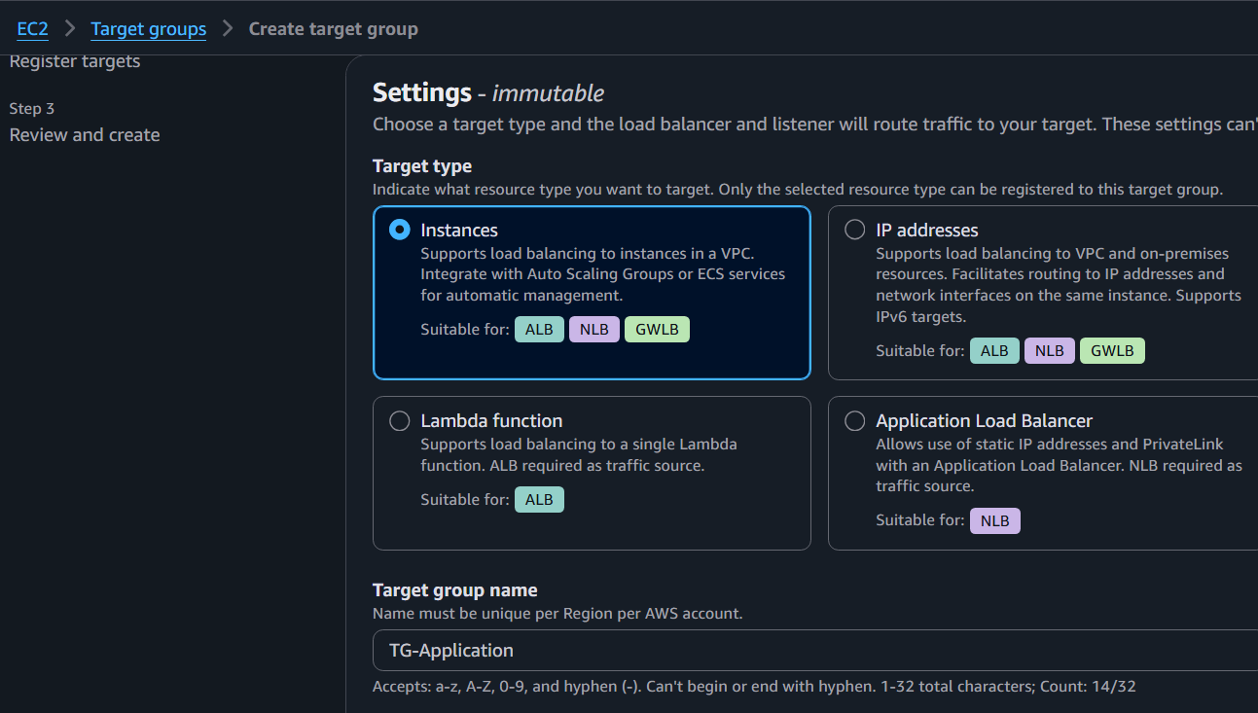
Health Check
/
HTTP
Next
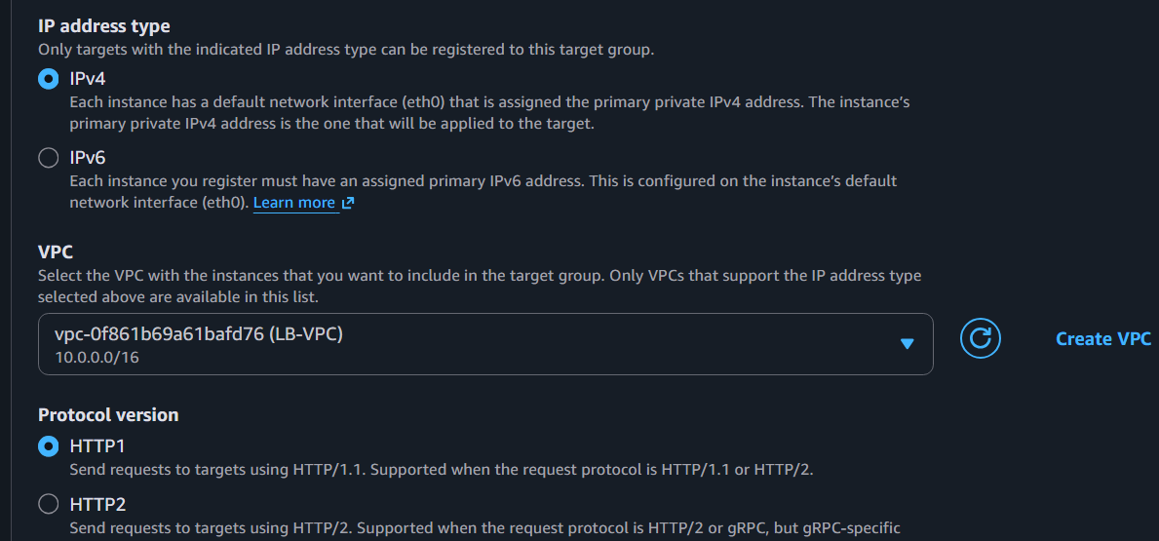
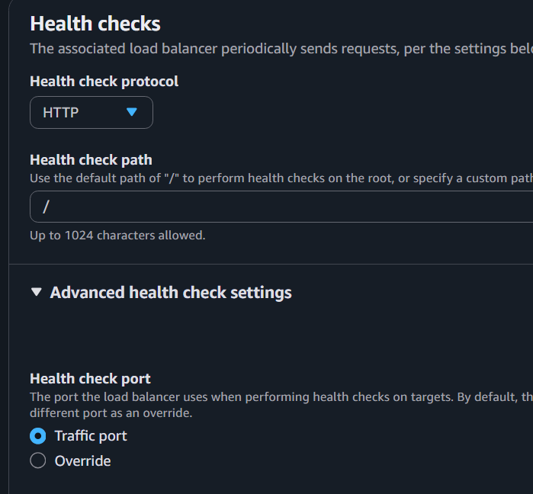
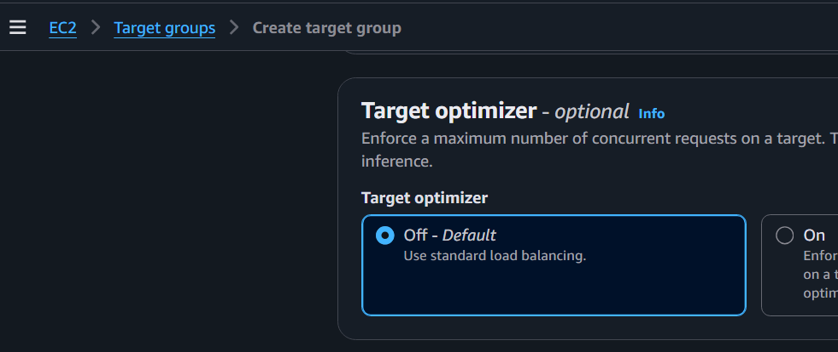
Register
EC2-1
EC2-2
Create
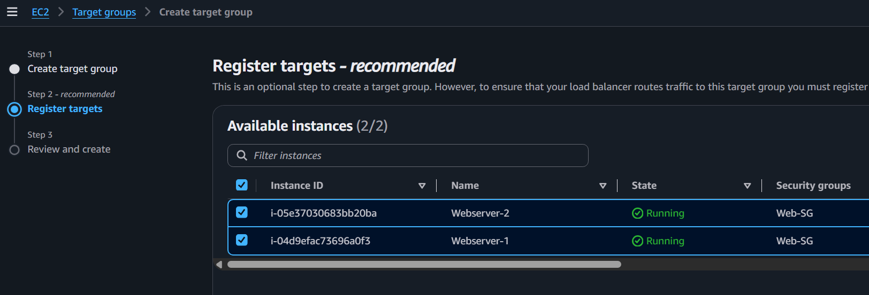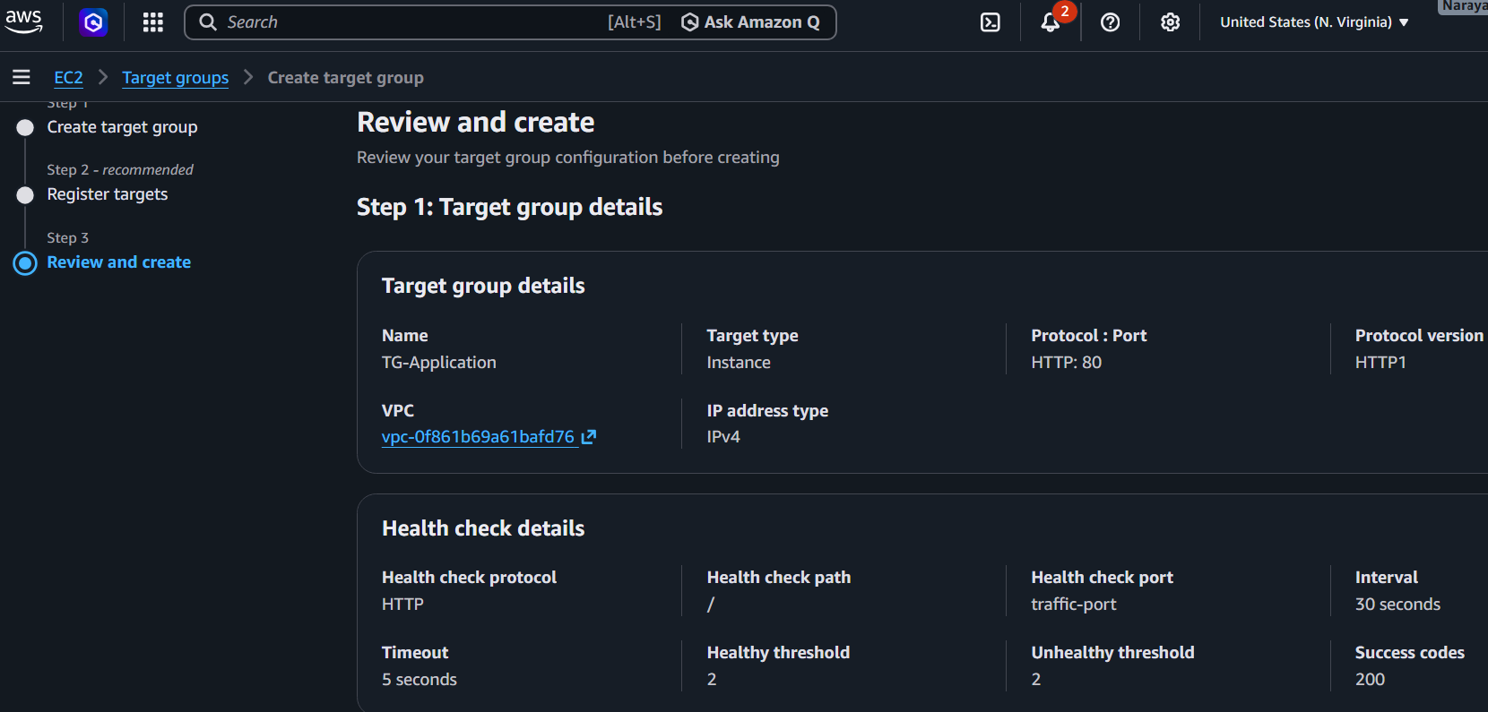
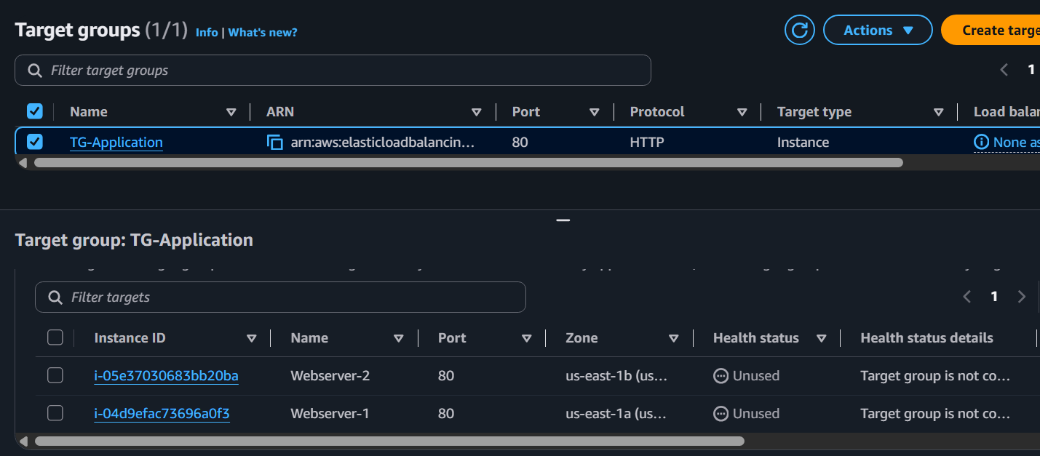

Attach Target Group
Finish
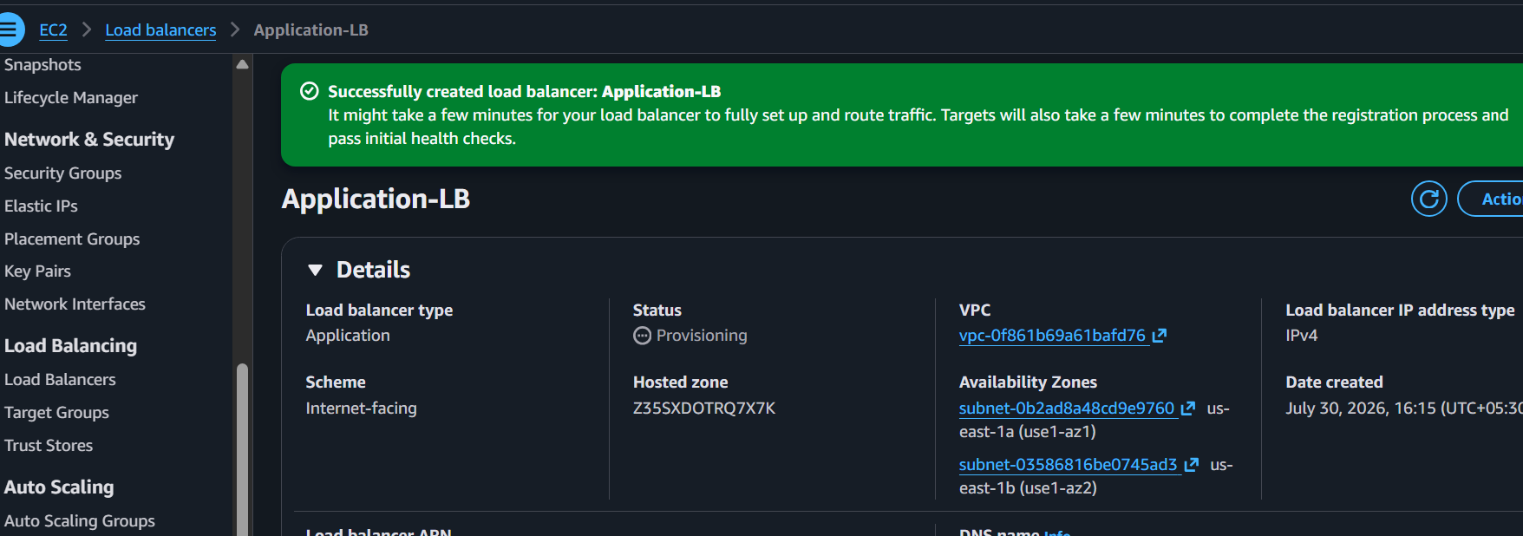

Copy DNS
http://application-lb-345076420.us-east-1.elb.amazonaws.com/
Open
http://ALB-DNS
Refresh
Traffic alternates
Server 1
Server 2
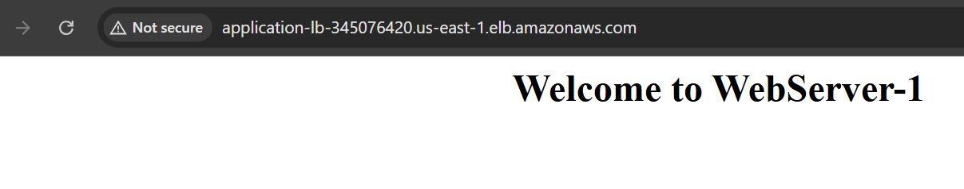
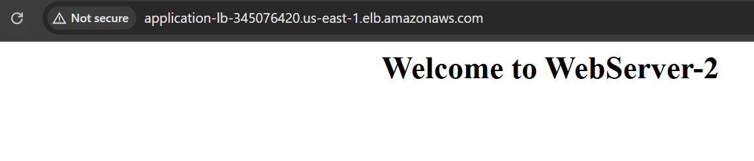

TASK 3: Configure Network Load Balancer

Create
Load Balancer
Choose
Network Load Balancer

Name
Network-LB
Scheme
Internet Facing
Listener
TCP
80
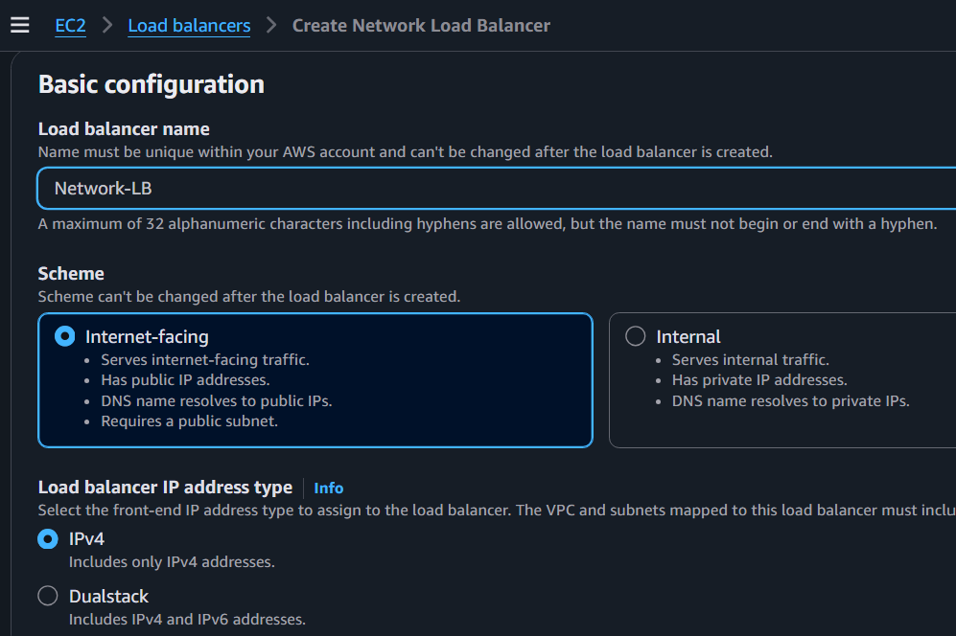
Select
Public Subnet A
Public Subnet B
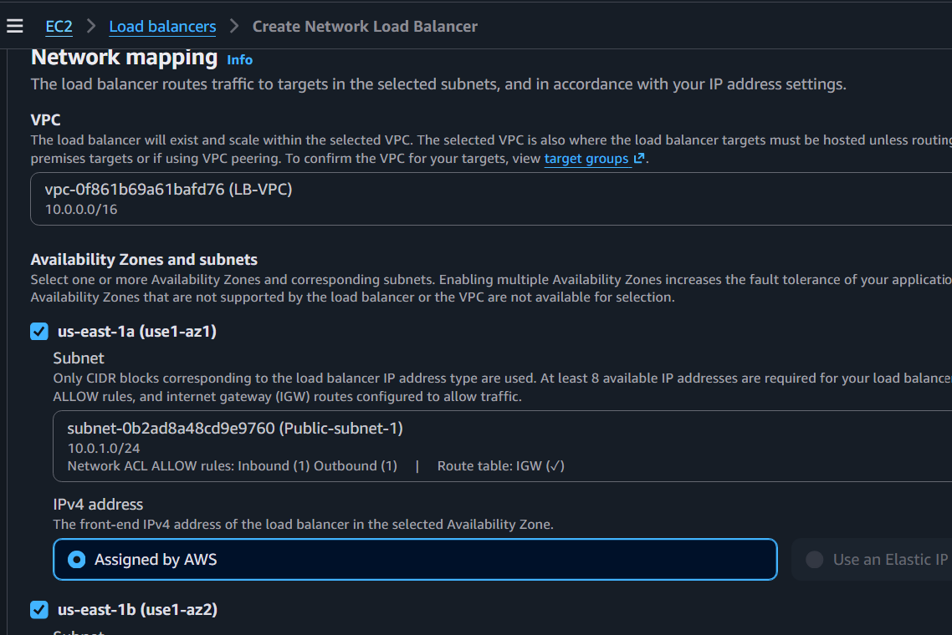

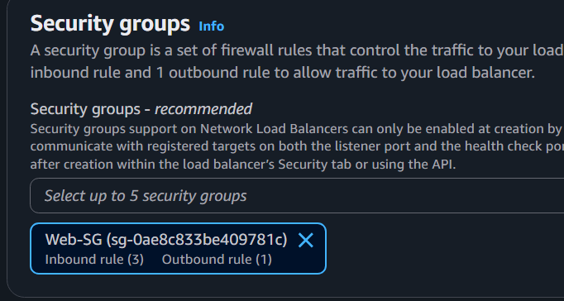
Create Target Group
Target Type
Instances
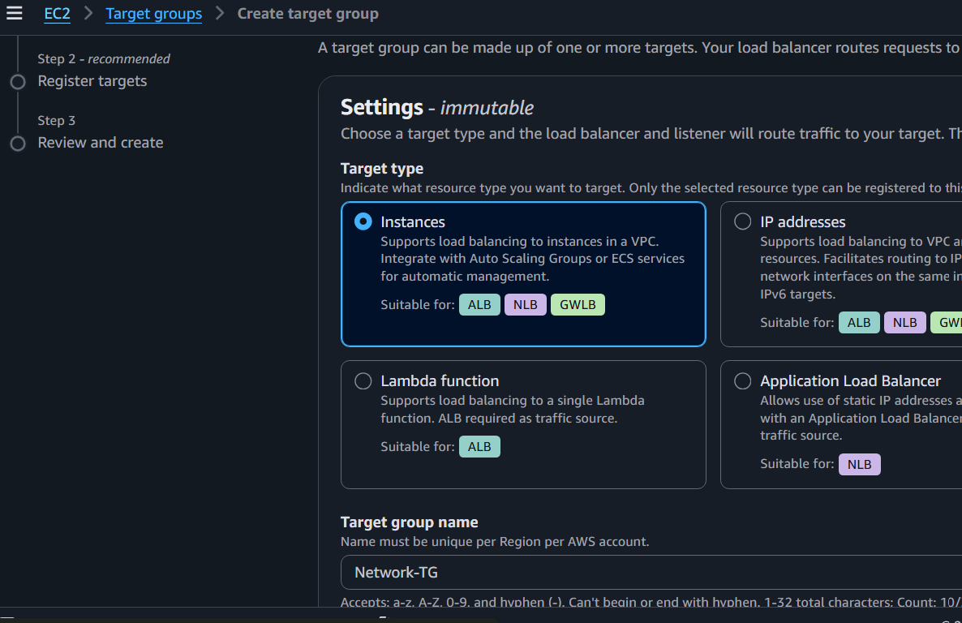
Protocol
TCP
Port
80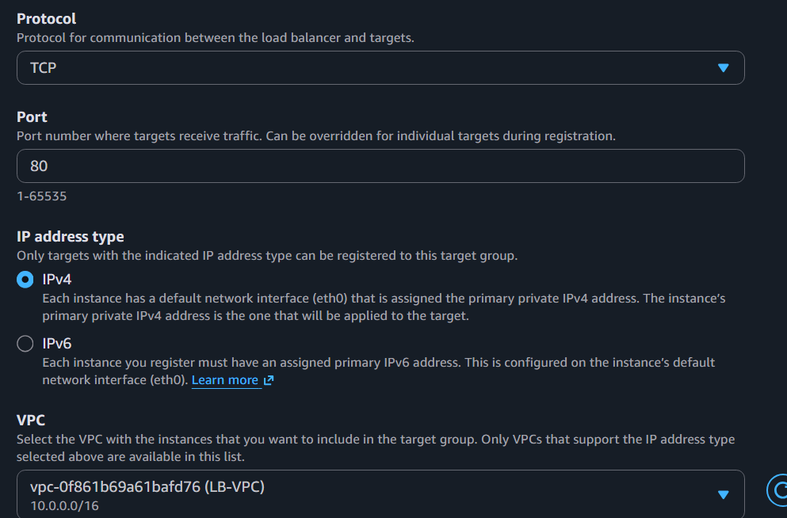
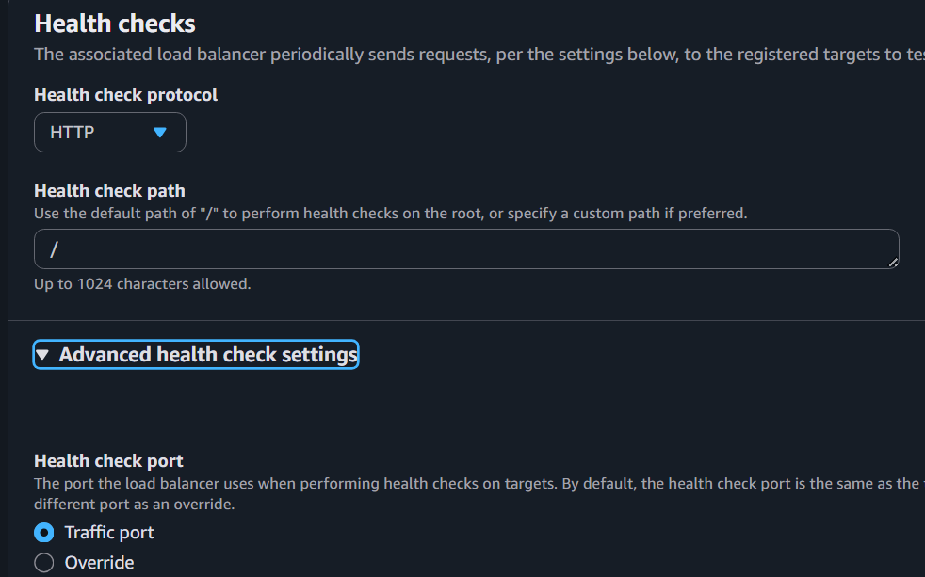

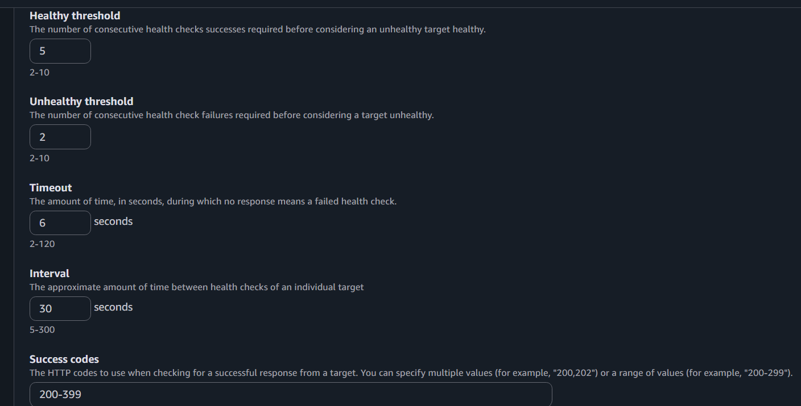
Register
EC2-1
EC2-2
Finish
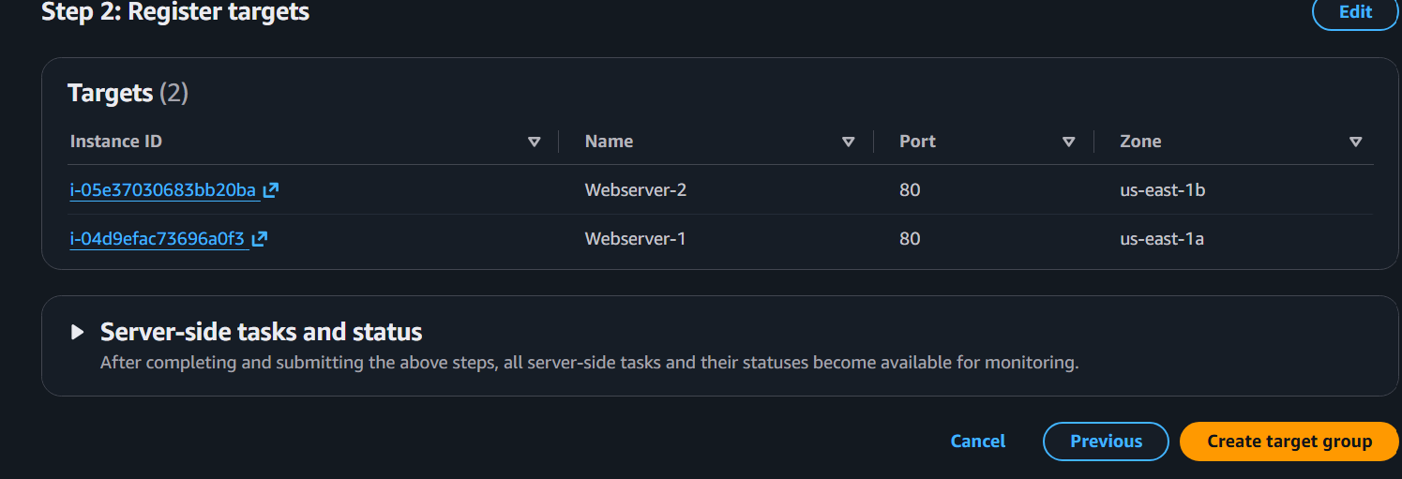
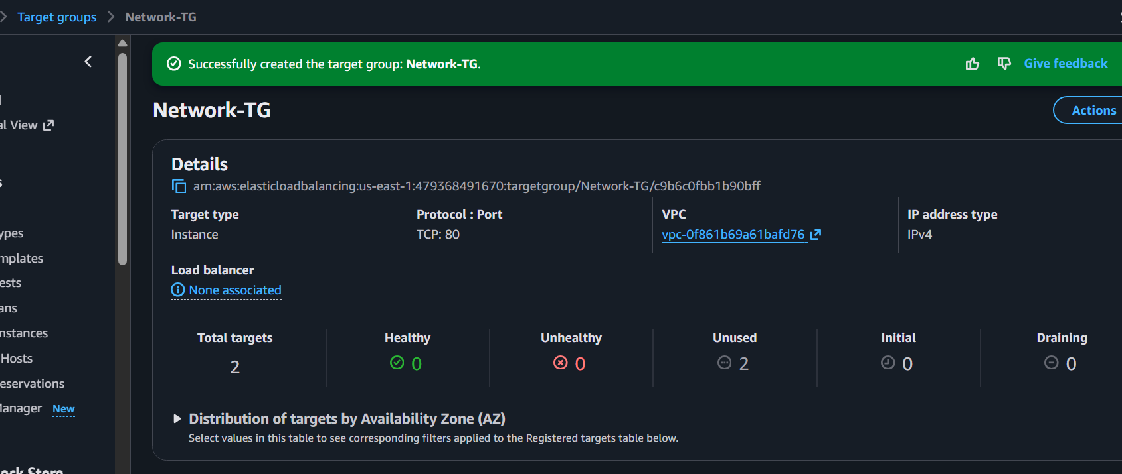
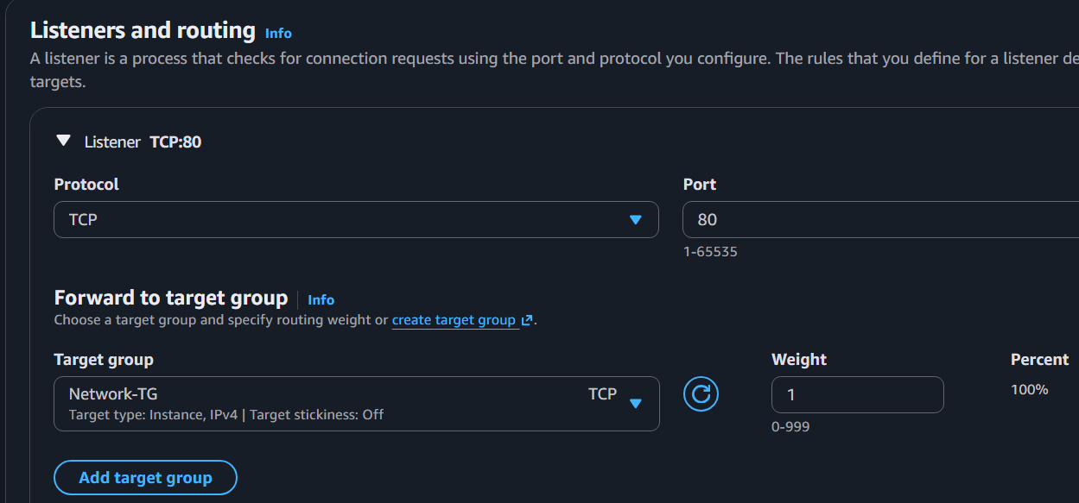

Copy DNS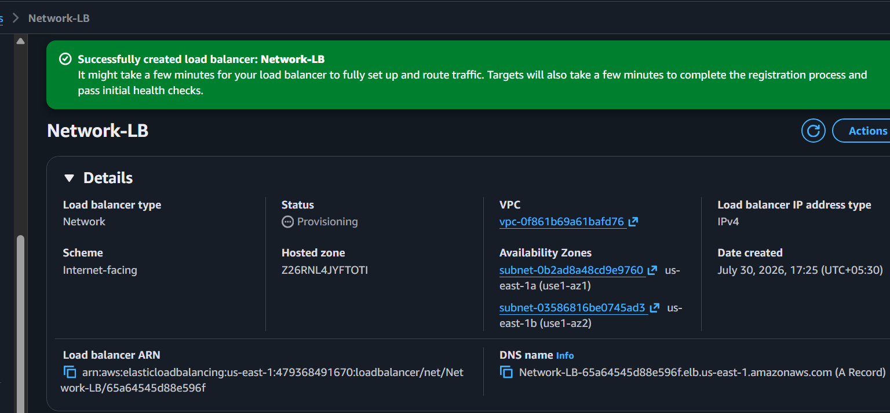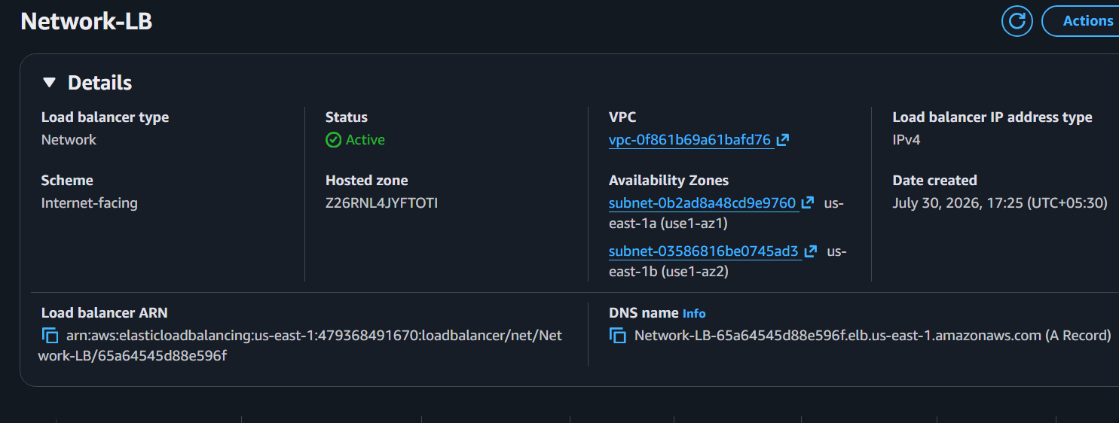
network-lb.elb.amazonaws.com
Open
http://NLB-DNS
Works exactly like ALB
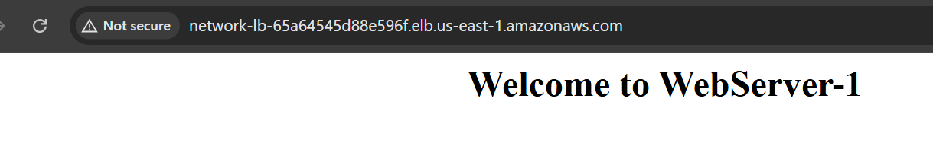

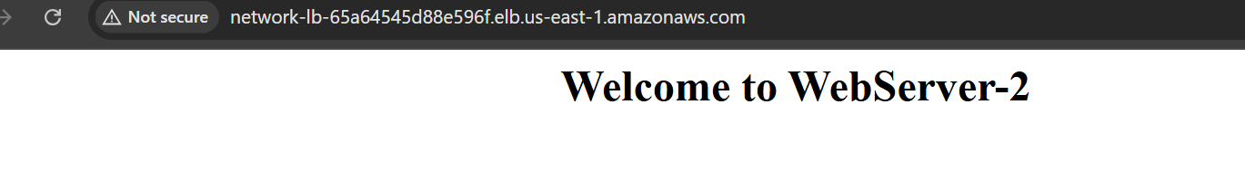

TASK 4: Attach SSL Certificate to ALB
We need:
- Domain
- ACM Certificate

Step 1
Go to
Certificate Manager (ACM)
Request Certificate
Public Certificate
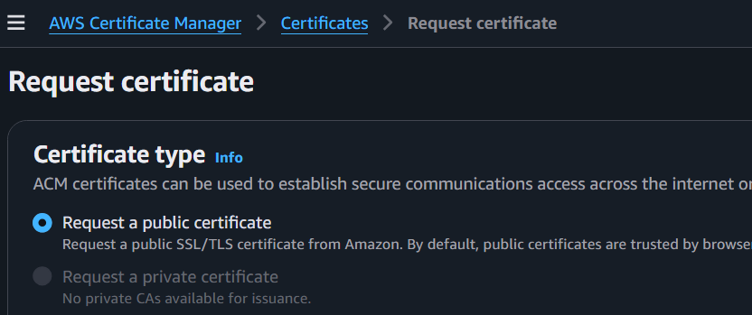

Domain
example.com

*.example.com
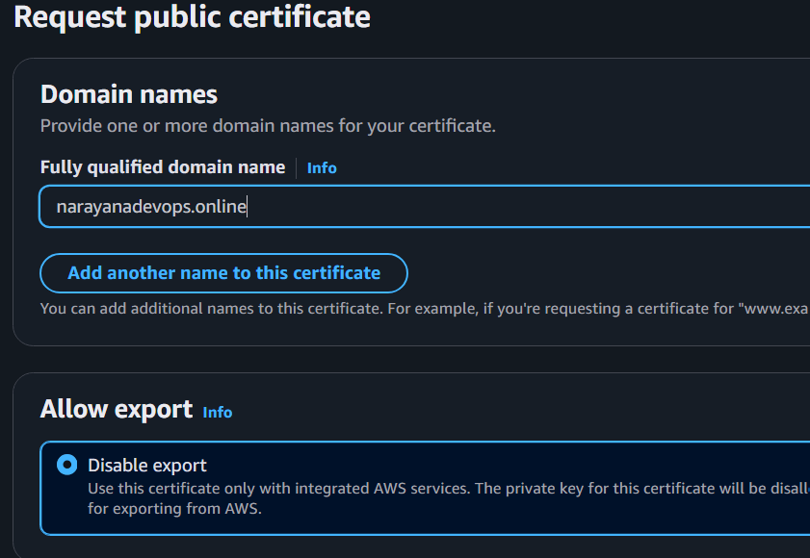
Next
Validation
DNS Validation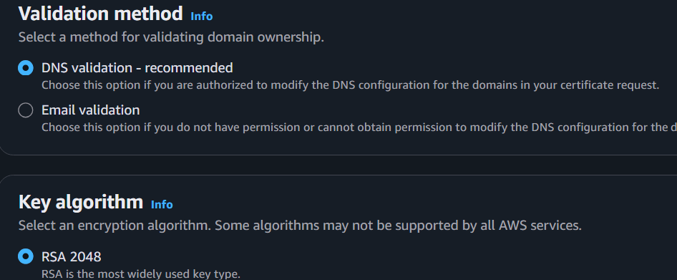
Finish
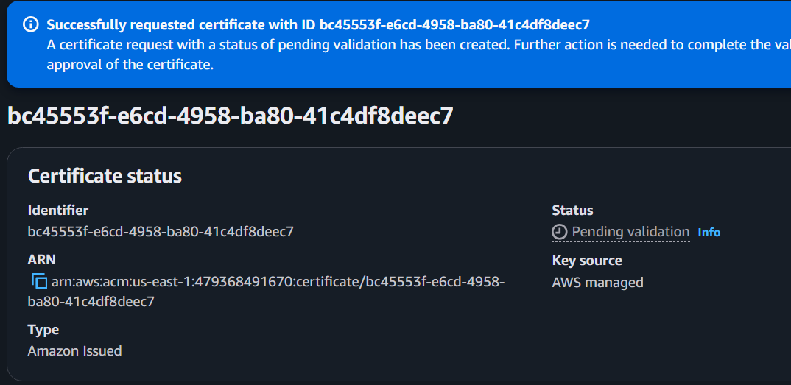

Recreate the Route 53 Hosted Zone
- Go to Route 53 → Hosted Zones.
- Create a new hosted zone:
  - Domain name: narayanadevops.online
  - Type: Public Hosted Zone
- After creation, Route 53 will generate 4 NS records.
- Log in to GoDaddy.
- Go to My Products → DNS → Nameservers.
- Replace the current nameservers with the 4 Route 53 nameservers.
- Save the changes.
If Route53 hosts domain
Click
Create Record
Certificate becomes
Issued
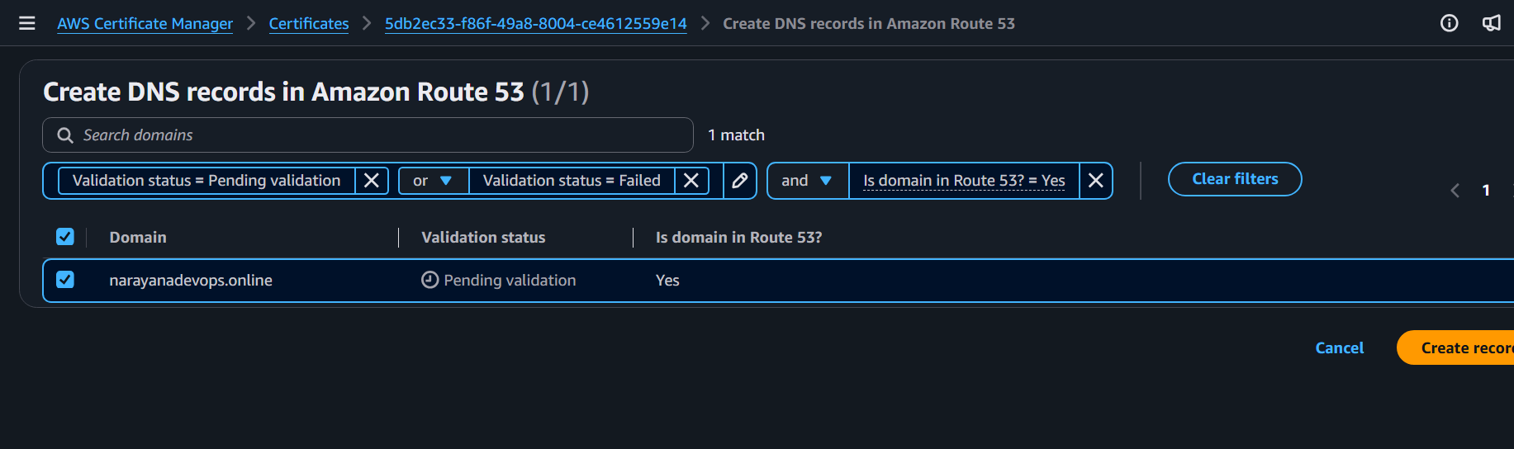
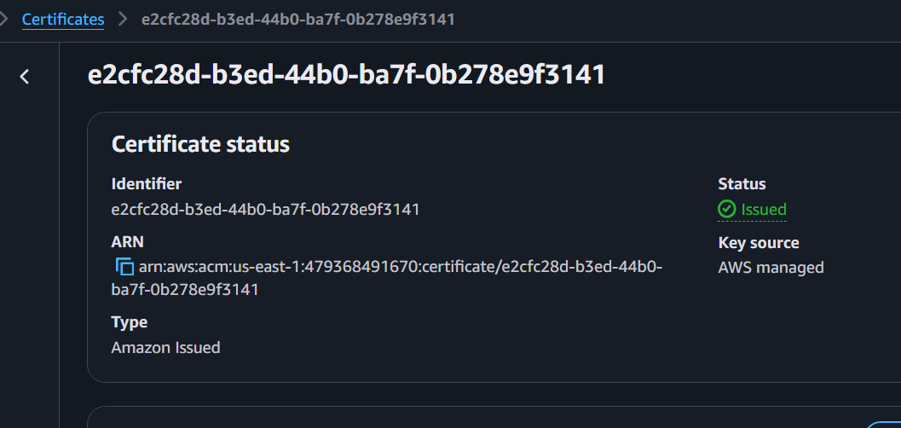

Step 2
Go
EC2
Application Load Balancer
Listeners
Add Listener
Choose
HTTPS
443
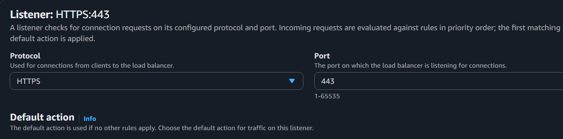
Choose
ACM Certificate
Select
Issued Certificate
Save
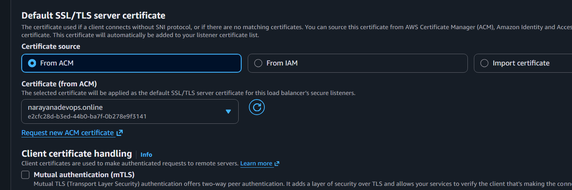

Optional
Redirect
HTTP → HTTPS
Listener
HTTP
Edit
Redirect
443
Now
http://narayanadevops.online
↓
https://narayanadevops.online

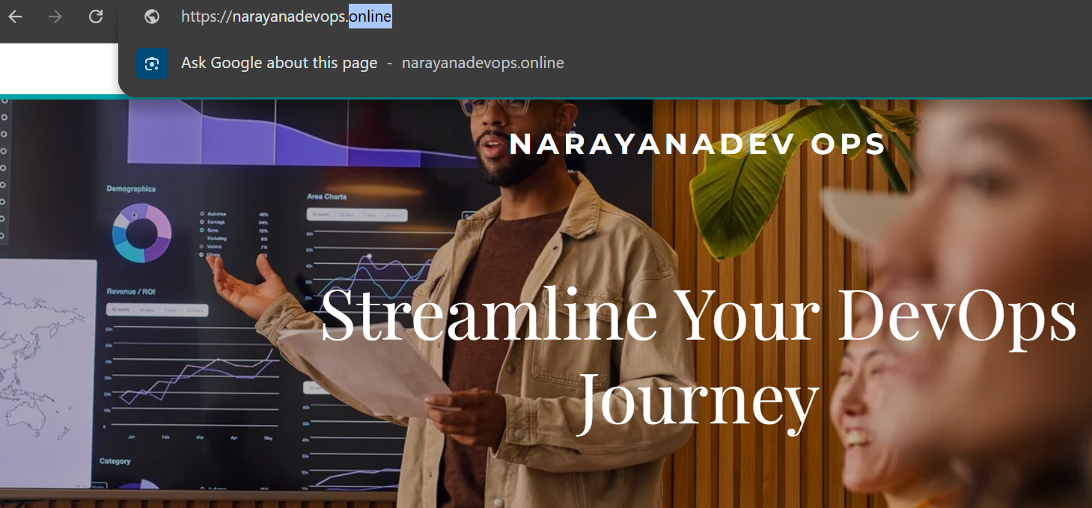

TASK 5: Map ALB to Route 53

Go
Route53
Hosted Zones
Create Hosted Zone
example.com

Update Nameservers at your domain registrar (for example, GoDaddy) with the four NS records provided by Route 53.

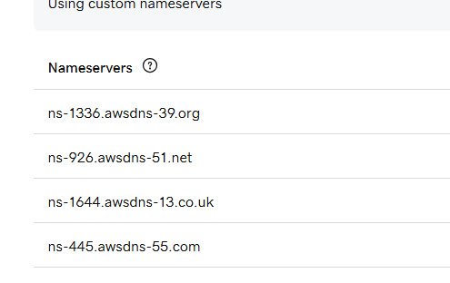
Create Record
Type
A
Alias
YES
Alias Target
Application Load Balancer
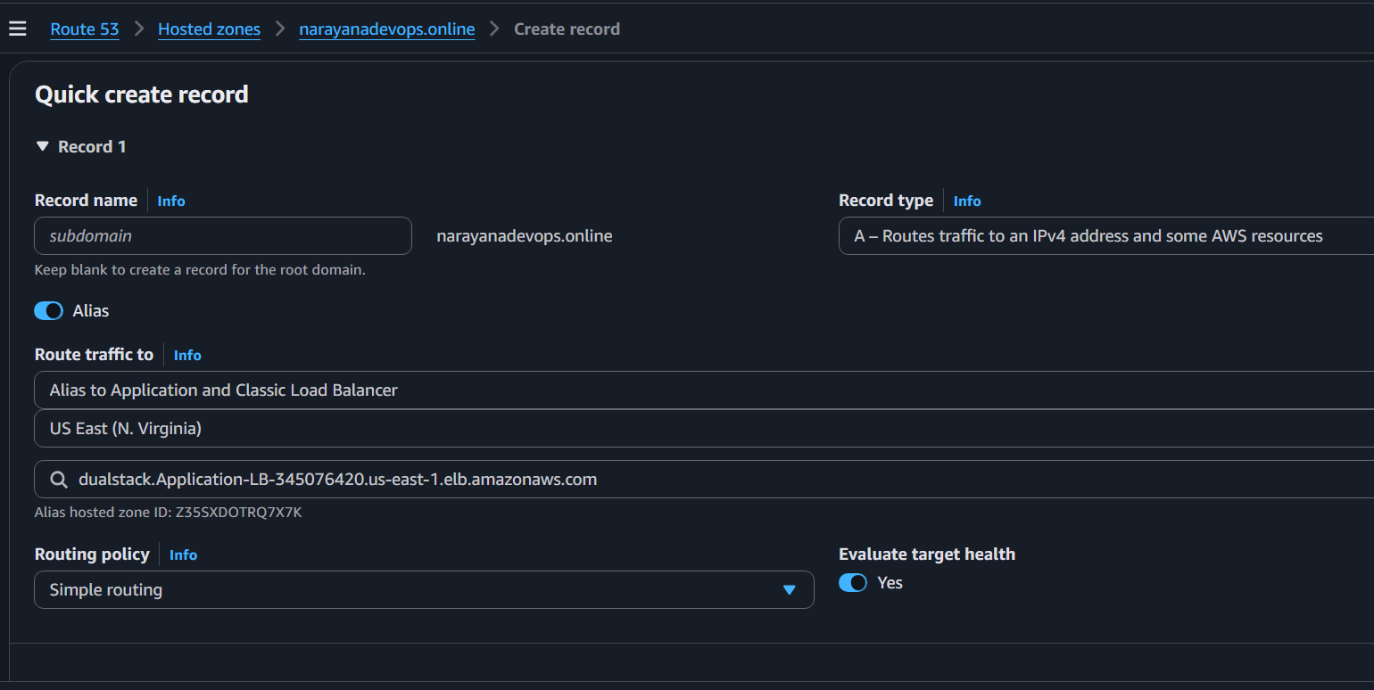
Save

Wait
5-10 minutes
Open
https://example.com
Application opens securely.
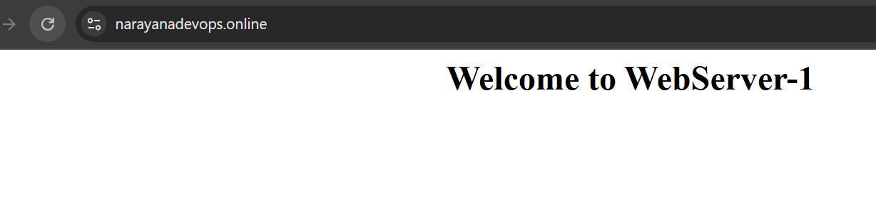
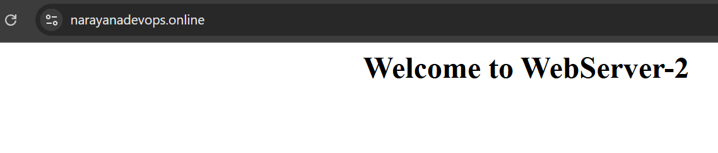

TASK 6: Push ALB Access Logs to S3

Step 1
Create S3 Bucket
Example
alb-logs-app
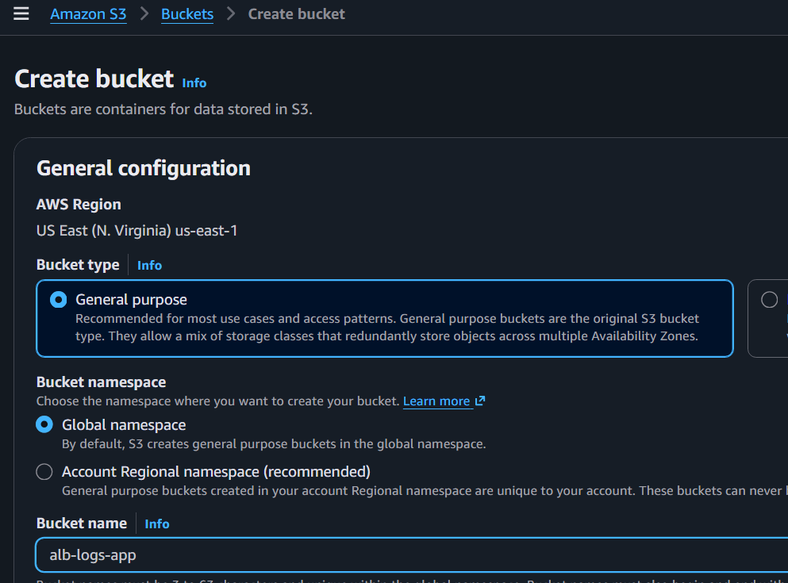
Block Public Access
ON
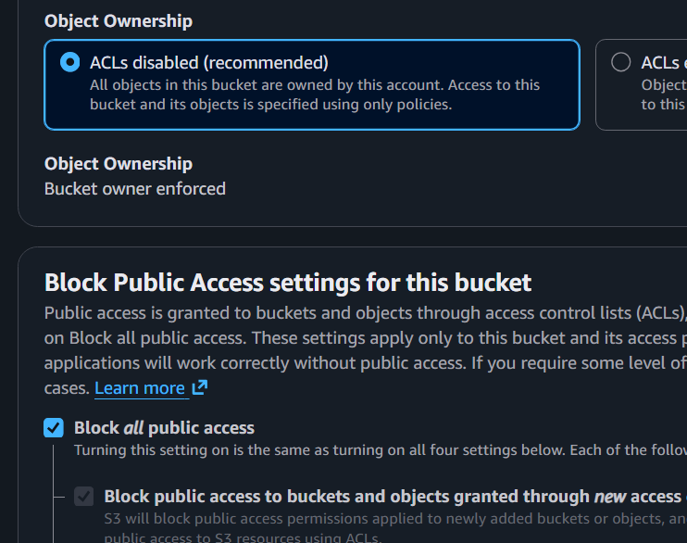

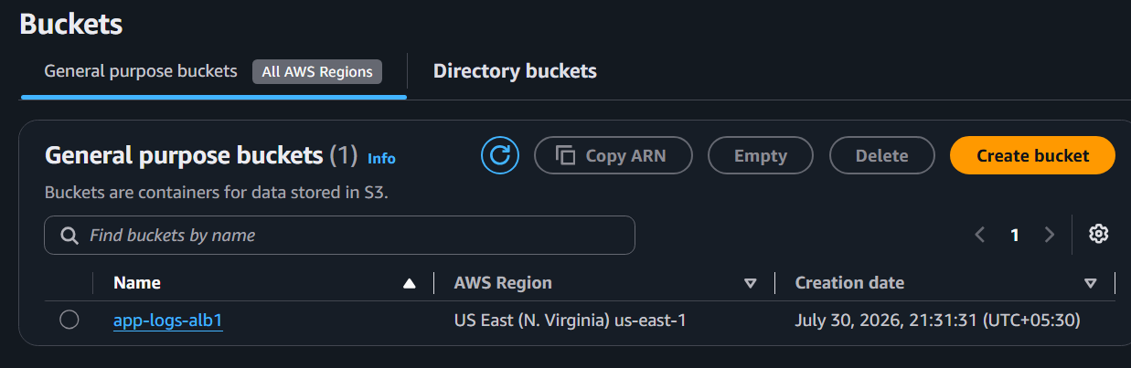
Step 2
Add Bucket Policy
Replace:
YOUR_BUCKET_NAME
YOUR_REGION
YOUR_ACCOUNT_ID
with your values.
{
"Version":"2012-10-17",
"Statement":[
{
"Effect":"Allow",
"Principal":{
"Service":"logdelivery.elasticloadbalancing.amazonaws.com"
},
"Action":"s3:PutObject",
"Resource":"arn:aws:s3:::YOUR_BUCKET_NAME/AWSLogs/YOUR_ACCOUNT_ID/*"
}
]
}

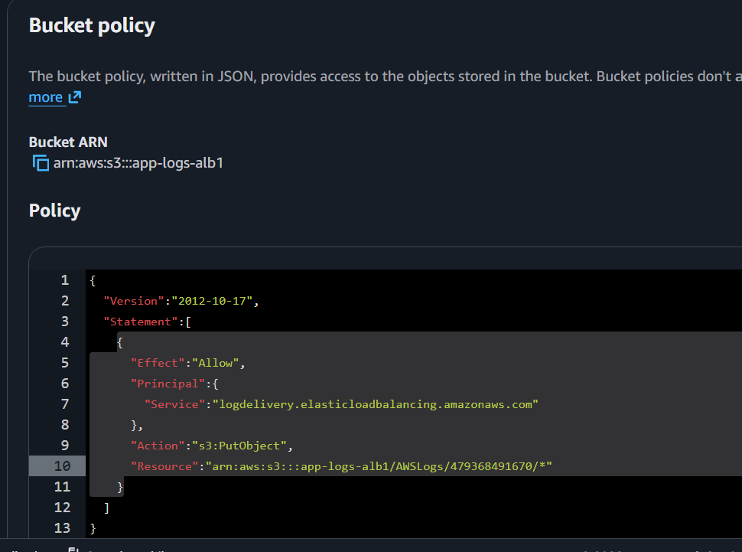
Step 3
Open
EC2
Load Balancers
Application Load Balancer
Attributes
Edit
Enable
Access Logs
ON
Bucket
App-logs-alb1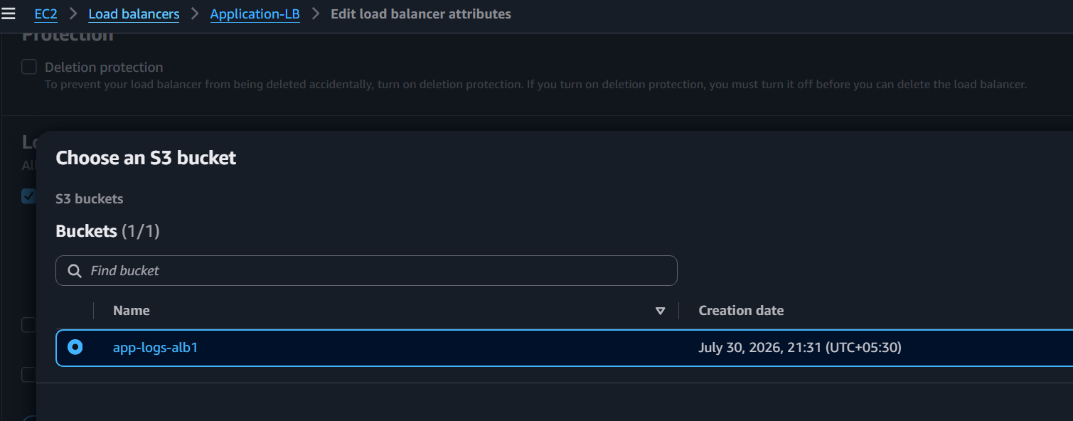
Prefix
logs
Save
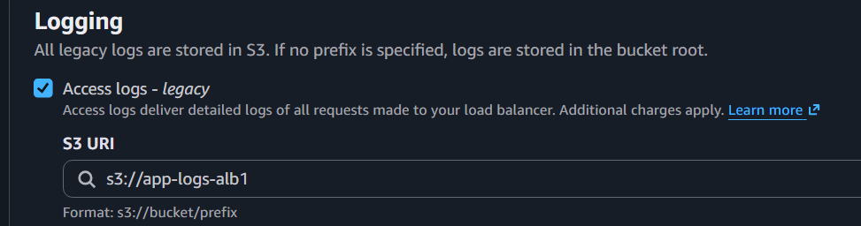

Step 4
Generate Traffic
Refresh
https://narayanadevops.online
20–30 times or use:

Step 5
Open S3
alb-access-logs-demo
You should see a structure similar to:
logs/
AWSLogs/
123456789012/
elasticloadbalancing/
eu-north-1/
2026/
07/
30/
xxxxxxxx.log.gz
Download and extract a .log.gz file to inspect the requests handled by the ALB.
